Active Directory Lab 01
Creating Organizational Units (OUs) and Users in Active Directory
Objective
The objective of this lab was to understand the basic administration of Active Directory by creating Organizational Units (OUs) and manually adding user accounts within a Windows Server domain environment. The lab also demonstrated how to organize users into departmental OUs and configure account properties such as password settings. This exercise provided practical experience with the Active Directory Users and Computers (ADUC) management console, which is widely used in enterprise environments for identity and access management.

Lab Environment
Component | Details
Operating System | Windows Server (Domain Controller)
Client Machine | Windows 10/11
Virtualization | VMware Workstation / VirtualBox
Domain | mydomain.com
Tool Used | Active Directory Users and Computers (ADUC)

Step 1: Starting the Virtual Machines
The lab environment was initialized by starting both the Domain Controller and the Windows client virtual machines using VMware Workstation. After the operating systems completed the boot process, both virtual machines were verified to be connected to the same virtual network. This ensured proper communication between the client machine and the Domain Controller before performing any Active Directory administrative tasks.
Result
Both virtual machines started successfully, and the Domain Controller was accessible for further configuration. 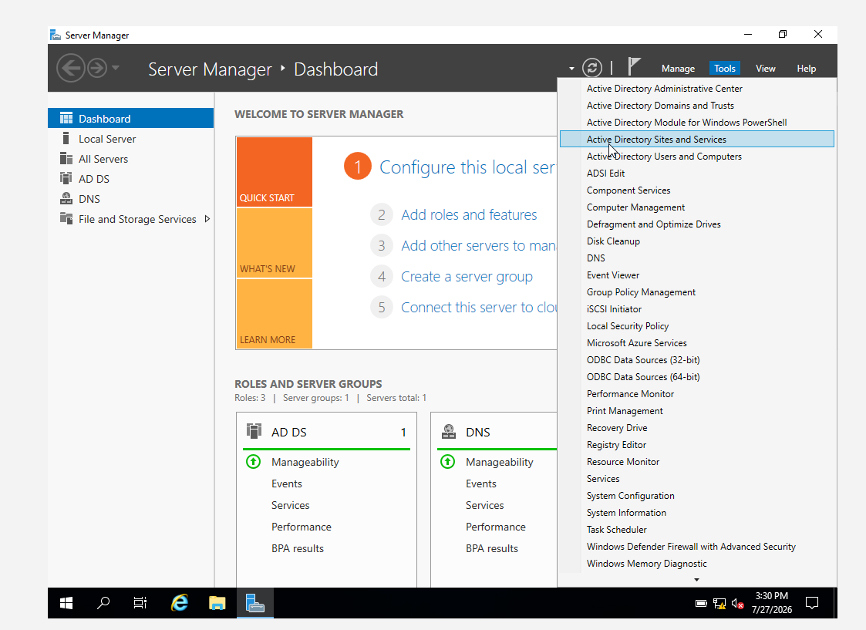

Step 2: Opening Active Directory Users and Computers
After logging into the Windows Server Domain Controller, the Active Directory Users and Computers (ADUC) management console was launched through Server Manager → Tools → Active Directory Users and Computers. The console displayed the existing domain structure of mydomain.com, allowing administrative tasks such as creating Organizational Units and user accounts to be performed.
Result
The ADUC console opened successfully and displayed the complete Active Directory domain hierarchy.
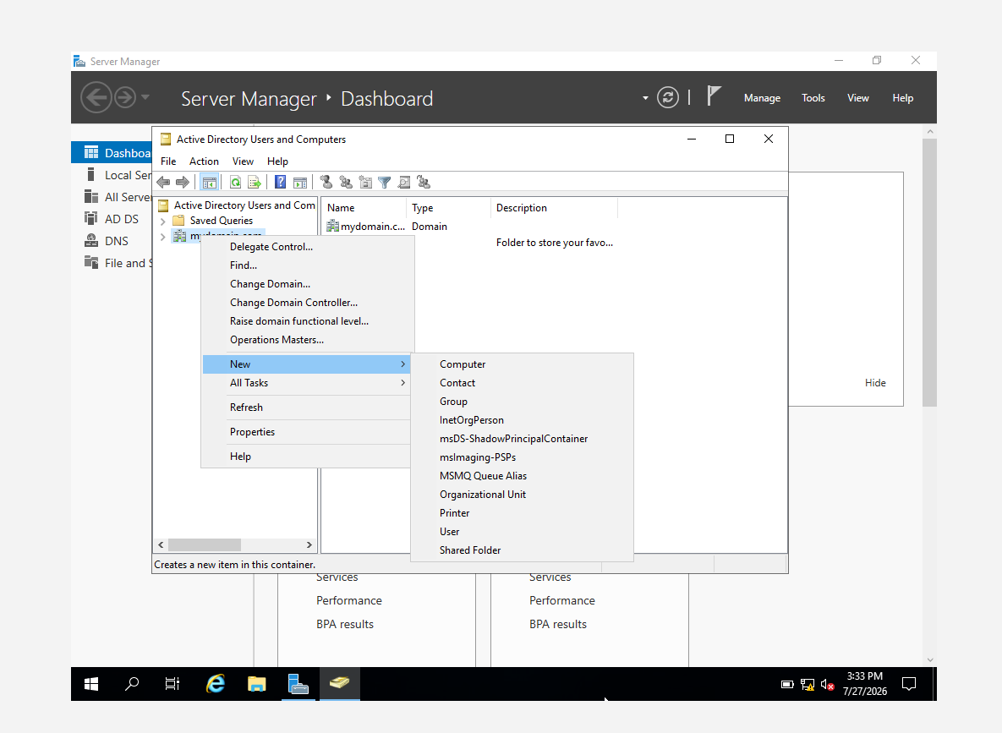

Step 3: Creating Organizational Units (OUs)
To organize the Active Directory environment, several Organizational Units (OUs) were created under the domain mydomain.com. Separate OUs were created for administrators, employees, and groups. Within the _EMPLOYEES Organizational Unit, additional child OUs were created to represent different organizational departments including IT, HR, and Sales.
The resulting Active Directory structure was organized as follows:
mydomain.com
│
├── _ADMINS
│
├── _EMPLOYEES
│ ├── IT
│ ├── HR
│ └── Sales
│
└── _GROUPS
Organizational Unit Structure
Parent OU | Child OU
mydomain.com | _ADMINS
mydomain.com | _EMPLOYEES
_EMPLOYEES | IT
_EMPLOYEES | HR
_EMPLOYEES | Sales
mydomain.com | _GROUPS
Result
The Organizational Unit hierarchy was successfully created according to the planned Active Directory structure, enabling proper administrative organization of departmental resources.
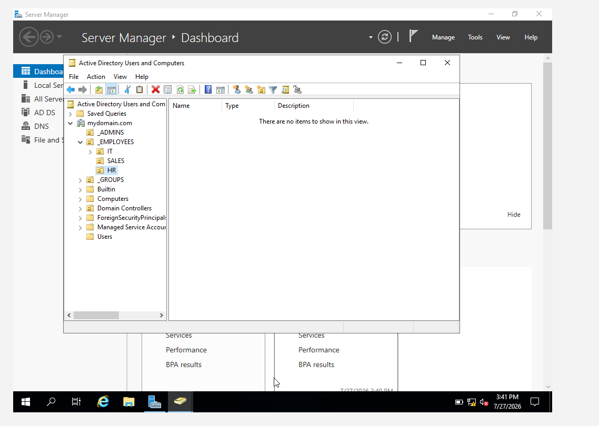

Step 4: Creating User Accounts
User accounts were manually created within their respective departmental Organizational Units using the New User wizard in Active Directory Users and Computers. During account creation, each user was assigned the predefined password P@ssw0rd123, and the Password never expires option was enabled to prevent password expiration during the lab.
The following user accounts were created:
Username | Department
john.doe | IT
jane.smith | HR
bob.wilson | Sales
alice.johnson | IT
charlie.brown | HR

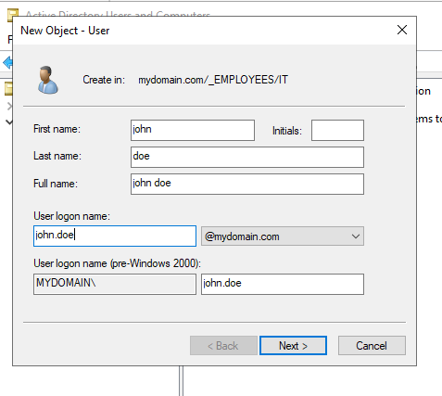Password Configuration
- Password: P@ssw0rd123
- Password never expires: Enabled 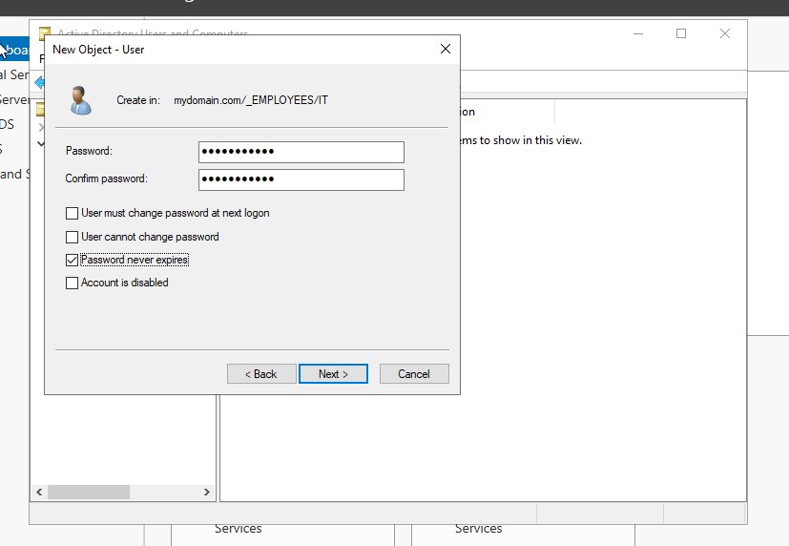
Result
All user accounts were successfully created and placed in their corresponding Organizational Units based on departmental requirements.

Step 5: Verifying User Properties
After creating all user accounts, each account's properties were reviewed through the Account tab in Active Directory Users and Computers. The configuration was verified to ensure that the Password never expires option was enabled for every user account. This verification confirmed that all user accounts were configured consistently according to the lab requirements.
Result
All user accounts were successfully verified, and the required password policy was correctly applied.
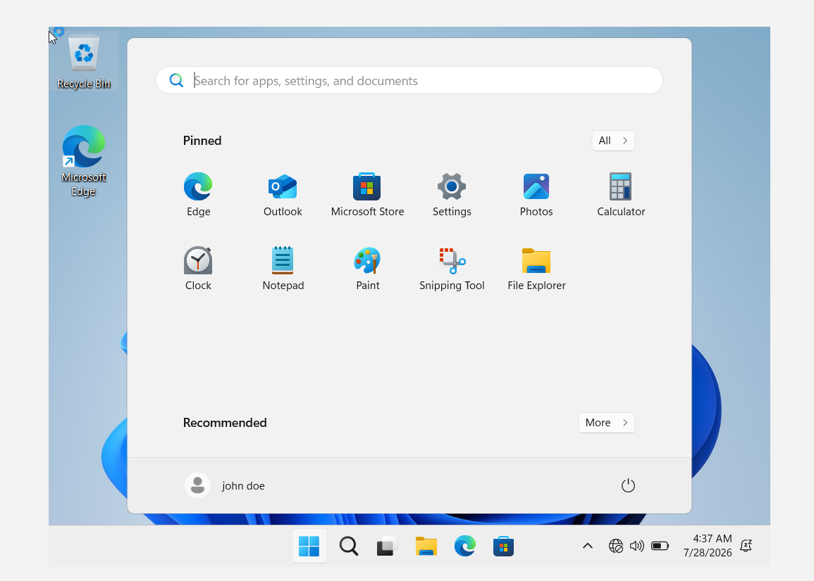
Conclusion
This lab provided practical experience with the fundamental administrative tasks performed in Active Directory. Organizational Units were successfully created to establish a structured domain hierarchy, and user accounts were organized according to their respective departments. Password policies were configured and verified for all users, demonstrating the process of managing identities within a Windows Server domain. The completed lab strengthened understanding of Active Directory administration and the importance of structured user management in enterprise environments.

